Abstract Submission Guidelines for Paper and Poster Presentations
(Guidelines for Section Chairs)

Academy Treasurer sends contact information to Section Chairs Friday, Oct 7, 2017
Section chairs send out letter to membership: Friday, Oct 14, 2017
Receipt of abstracts by section chairs: Friday, Dec. 8, 2017
Receipt of bulk upload spreadsheet by Assoc. Editor: Friday, Jan 12, 2018
Return of formatted bulk upload info to Section Chairs: Friday, Jan 19, 2018
Receipt of section programs by Tech Program Chair: Friday, Jan 26, 2018
Final program due to Assoc. Editor: Friday, Feb 2, 2018

Other important dates to remember:
Program planning meeting (via teleconference): Friday, Oct 20, 2017
Fall Council meeting (via teleconference): Friday, Oct 27, 2017
Winter Council Meeting (via teleconference) ? Friday, Jan ??, 2018
Academy Secretary must receive section ballots by: Thursday, Feb ??, 2018
Annual meeting: April 13-14, 2018

Letter of announcement from section chair to membership
1. Please send out a letter of announcement to your section membership for paper presentations at the 2018 Annual Meeting of Georgia Academy of Science. The meeting will be held on Friday, April 13th and Saturday, April 14th at the University of West Georgia, Carrollton, Georgia. You will receive contact information for each member of your section by the end of September; if you do not receive this information, contact the Academy Treasurer (Jim Nienow, jnienow@valdosta.edu ).

2. The letter of announcement consists of three parts; (a) call for papers; (b) call for section officer nominations; and (c) call for referees. Note that the call for papers includes the location and date of the conference, the deadline for abstract submission to the section chair, and reference to the Academy website at http://www.gaacademy.org. This website includes links to the Annual Meeting which contains the abstract form and submission guidelines. Information about poster judging and student travel awards can also be found there. Accommodations, travel directions and other general information about the conference will also be posted on the website as soon as this information becomes available.
As an incentive to motivate abstract submission, indicate two special opportunities: (1) competitive monetary awards for undergraduate and graduate student oral presentations and poster presentations; and (2) the possibility of developing an oral presentation into a manuscript to be considered for publication in the Georgia Journal of Science. This latter opportunity applies to both student and faculty oral presentations. Additionally, if your section has a preference for oral presentations over poster presentations, it would be appropriate to indicate this preference in the call for abstracts.
In the call for officer nominations, indicate that specific officer duties are described on the Academy website, under the GAS Constitution link (in particular, see article V). In the call for referees, indicate the duties of the referee, the date by which you will provide abstracts to the referees, and the date by which you will need the reviewed abstracts returned.

3. Please send out subsequent calls for papers to the membership as appropriate to encourage participation (and remind people of the submission deadline). Actively recruit presenters, referees, and officer candidates by any appropriate means.

Abstract review process and submission to Technical Chair
Upon receiving abstracts by the abstract submission deadline in December, section chairs must do the following:
1. Save a copy of the abstract submission form.
2. Acknowledge receipt of the abstract by email reply.
3. Forward the abstract by e-mail attachment to referees.

4. Section chairs and referees are free to make minor editorial changes (grammatical errors, spelling errors, typographical errors, form, etc.) Contact the authors of those abstracts in need of major revisions (any content change, excessive revision for grammar, expression or form) as soon as possible. If the author does not make the necessary changes as recommended by the section chair, the submission may be rejected. Or, at the discretion of the section chair, the abstract may be accepted for presentation, with only the title, presenter’s name and affiliation published in the journal.

5. Upon completion of the review process, prepare the bulk upload excel spreadsheet file (each submission is copied & pasted as a column on the same sheet) for submission to the Associate Editor (Frank Corotto, frank.corotto@ung.edu). Send a copy of this file to the Academy Secretary (Joe Sloop, jsloop@ggc.edu) as well. The order of the abstracts should be the same as they should appear in the section program. Construct the section program according to the guidelines below.

6. By the second week of February the section chairs will receive a draft copy of the final program from the Technical Program Chair. Section Chairs should notify the authors about the status of their abstracts (e.g., acceptance or rejection) via email.

Scheduling presentations
After all abstract submissions have been reviewed and revised as necessary, please make a program schedule for your section according to the following guidelines:

- Presentations are divided into two sessions: Friday from 1:00 – 5:00 pm and Saturday from 7:30 – 10:00 am, and 10:30 am – 12:00 pm. If there are not enough presentations to fill all the time slots on both Friday and Saturday, fill all time slots on
Saturday and schedule the remaining presentations on Friday. If there are not enough presentations to fill the Saturday morning schedule, schedule your first presentation late enough (after 7:30) such that the last presentation ends at 12:00.

2. Do not schedule presentations from 10:00 – 10:30 Saturday morning. This time will be reserved for section business meetings. Posters may also be available for viewing at this time.

3. Schedule all student presentations before 10:00 am on Saturday morning. It is desirable to schedule all student presentations on Saturday morning in order to promote attendance at the luncheon. Some student presentations may be scheduled on Friday afternoon due to lack of time slots on Saturday morning, and due to lack of judges available on Saturday morning. Those student presentations scheduled for Saturday morning must be finished by 10:00 am so student presenters can be considered for awards prior to the plenary session Saturday afternoon. Schedule faculty presentations in whatever order you deem to be fair and appropriate. Some examples of rationales for scheduling papers include (but are not limited to) the following: (1) It may be necessary to schedule a paper at a certain time because the presenter is also giving a paper in another section at another time slot; (2) closely related papers may be scheduled in sequence; or (3) scheduling priority may be given according to the order in which the abstracts were received.

4. Allow 15 minutes for each presentation. However, only in certain sections such as the Philosophy & History section each presentation is scheduled for 30 minutes. The section chair will be responsible for keeping presentations on schedule. This responsibility includes interrupting presenters that exceed the allotted time.
IMPORTANT: Do not move papers forward in the program if a presenter finishes early or fails to appear. Members from other sections depend on section chairs to follow the published schedule. Please have a plan in place for utilizing time constructively if a presenter is unexpectedly absent.

5. Avoid parallel sessions.

6. Schedule breaks as you see fit. After the technical program chair receives all section programs, breaks may be readjusted such that breaks are consistent across sections.

7. Upon completion of scheduling, construct the section program according to the guidelines that follow (for a sample see Vol 74 No. 1 - 2016 of the Georgia Journal of
Science from last year that can be accessed through the Academy Website) and send it to the Technical Program Chair.

Section program construction (do this from the Word doc you receive from the Associate Editor)
1. Use 12-point, Georgia font.

2. The heading of a section program consists of three entries, each centered on a separate line: Section number and name; Room number and building name; and the presider’s name, followed by “presider”. Some of this information may not be available at the time section chairs construct the program, and will be added by the technical program chair at a later stage. See the example below.
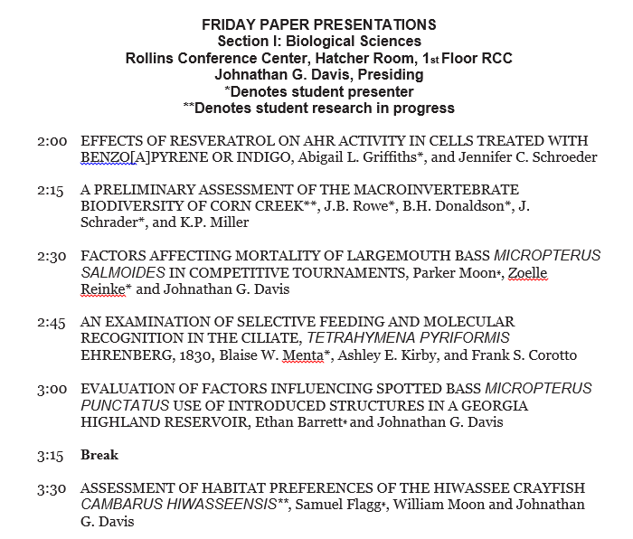
3. The section program body consists of a list of entries, as described in 4 - 8 below.

4. Each entry consists of a time, an abstract title, and the author list. The time is flush with the left margin; the rest of the entry is indented five spaces.

5. The time is in hh:mm format. Do not specify AM or PM.

6. The abstract title is in all caps. Latin names are italicized, and book titles, which may occur in book review presentation titles, are enclosed in single quotes.

7. List authors as listed on the abstract. Student author names are followed by a single asterisk. Do not include affiliations.

8. List posters at the end of the program on Saturday morning. Poster entries are not indented, but are listed flush with the left margin without a time given.

9. Send the completed program to the Technical Program Chair (Javier Hasbun, jhasbun@westga.edu).

Facilities
Certain standard equipment will be available in all the presentation rooms; this will be specified at the fall council meeting. Presenters who need additional equipment must specify this on the abstract submission form in the space for special equipment needs. The section chair will contact the local arrangements chair to determine if the equipment is available and advise the presenter accordingly. Questions about equipment should be directed to Local Arrangements Chair to Jennifer Schroeder. (jcschroeder@yhc.edu).

Submission of section program and other materials/official confirmation
Section chairs will send their finalized programs in a Microsoft Word document via email attachment to the Technical Program Chair (see calendar at top). The Technical Program Chair will add site-specific, front-matter to the program (e.g., letters, campus maps, schedule, etc.) and forward the final document on to the Associate Editor for upload to DigitalCommons.
The Journal Editor and the Technical Program Chair reserve the right to reject an abstract that does not meet Academy guidelines. In some cases, the abstract may be accepted for oral presentation with only the title, author and affiliation published in the journal.

Thereafter, Section Chairs will contact presenters to confirm presentation topic, special equipment needs, and date, location, and time of presentation. Section Chairs should also remind presenters that they:
- must be members of the Academy to present at the Annual Meeting,
- should register for the meeting early to avoid the late registration fee, and
- should notify the Section Chair as early as possible if the presenter is not able to attend the meeting.

If you have questions about the program construction, the deadlines, facilities, or anything related to the conference program, contact the Local Arrangements Chair. For general information about the Annual meeting and appropriate links please periodically visit the Academy meeting web page.

